How to approve the purchase order ME28 screen add custom fields

When the ME28 with a purchase order approval, would like to add fields on the ALV display screen, how?

Checked if nothing standard enhancement to achieve, maybe, but I did not find. . . .

debug ME28 found a BADI ME_CHANGE_OUTTAB, but unfortunately this is internal use, I was not inside the person, not take. . .

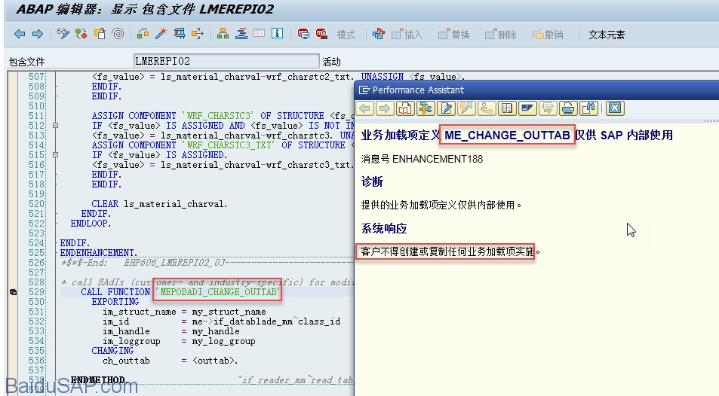

Below an example to explain the customer is on the field zjgfd and zcgsl take the following two purchase order line items added to the ME28 alv display on the screen.

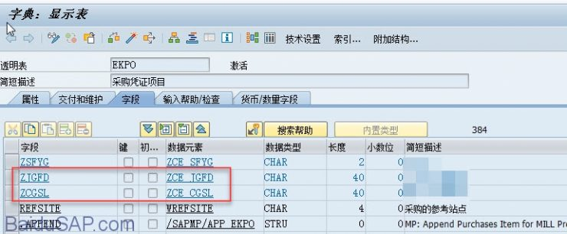

debug a bit me28, ALV found in the table shown in it include LMEREPI02 filled, and ls_outtab_purchdoc is used in the work area,

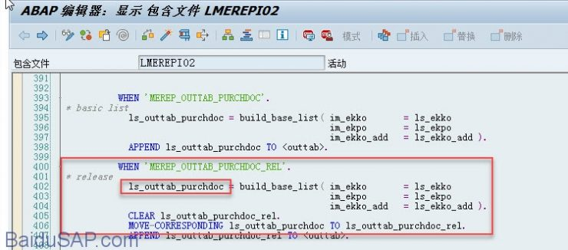

Then ls_outtab_purchdoc definition type MEREP_OUTTAB_PURCHDOC to be displayed in the two additional fields up.

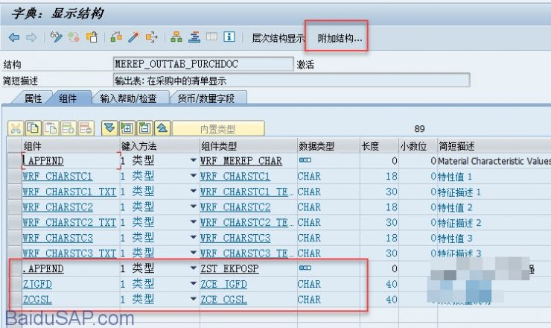

Then no then, and run a bit me28 actually succeeded. . . The new field is added from the layout to find out, or else not displayed.

